CHAPTER I
INTRODUCTION

  - Overview
In the serene district of Mehsana, Gujarat, the administrative landscape grapples with a myriad of challenges stemming from the absence of a unified dashboard. The District Collector faces the intricate task of managing and monitoring various projects and schemes spread across diverse departments. Delays in decision-making, difficulties in progress assessment, and challenges in resource allocation become pronounced due to the lack of a consolidated view. Mehsana's administrative processes are at a crossroads, necessitating a transformative solution.
- Absence of a unified dashboard.
- Delays in decision-making.
- Difficulties in progress assessment.
- Challenges in resource allocation.
Changes the Software Can Make:
The introduction of the District Integrated Dashboard promises a revolutionary shift in how Mehsana addresses its administrative challenges. The software serves as a comprehensive solution to the problems plaguing the district. By providing real-time updates on ongoing projects and schemes, the dashboard becomes the cornerstone for informed decision-making. Data visualization tools embedded in the software offer an intuitive comprehension of complex datasets, empowering users with meaningful insights. The integration capabilities ensure a seamless flow of information from various departments, eradicating silos and fostering collaboration.
- Real-time updates on projects.
- Intuitive data visualization tools.
- Seamless integration capabilities.
- Fostering collaboration and transparency.
The imperative for a solution becomes evident as the District Collector strives to enhance governance and overcome administrative bottlenecks. The District Integrated Dashboard emerges as a strategic ally, streamlining monitoring processes, and providing an immediate, consolidated view of ongoing projects. The software empowers decision-makers, facilitates resource optimization, and introduces a new era of efficiency in Mehsana's administrative processes.

  - Problem Statement
District Integrated Dashboard:
As a Head of District Administration, District Collector Don't have any Unified dashboard which gives the Progress details of Different ongoing Project/Schemes of Different Department.
Monitoring, Analyzing and Reviewing of Different Portal and Schemes. A District Integrated Dashboard is a digital tool or platform designed to provide comprehensive and real time information and data on various aspects of a specific district or locality.
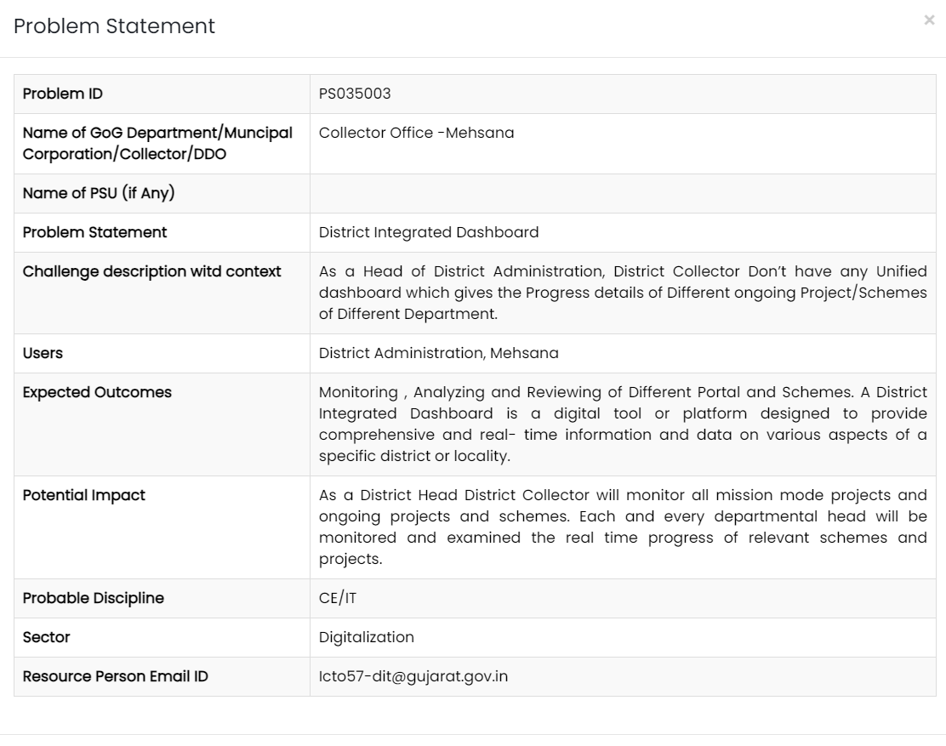
Figure 1 : SSIP problem statement
Website: https://ssipgujarat.in/hackathon2023/problem_statement.php
  - Objective of Project
The overarching objective of the District Integrated Dashboard project is to revolutionize the administrative landscape of Mehsana, Gujarat, by addressing the challenges faced in monitoring and managing various projects across departments. The primary focus is on providing the District Collector and administrative heads with a powerful tool that streamlines monitoring processes, ensures real-time updates on ongoing projects, and enhances decision-making capabilities. The project aims not only to bridge the existing gaps in information flow but to establish a robust and adaptable solution that evolves with the changing dynamics of the district's administrative requirements. The objective is rooted in the vision of creating a digital ecosystem that enhances governance efficiency and transparency.
- Streamline monitoring processes.
- Ensure real-time updates on ongoing projects.
- Enhance decision-making capabilities.
- Bridge existing gaps in information flow.
- Establish a robust and adaptable solution.
- Foster a digital ecosystem for efficient governance.
  - Applications or Scope
The scope of the District Integrated Dashboard project extends far beyond the development of a mere monitoring tool. It envisions a comprehensive application that transforms the way district administration operates in Mehsana. The applications of the dashboard are vast, reaching department heads, project managers, and various administrative officials. By offering transparency, accessibility, and efficiency, the project's scope encompasses not only ongoing projects but also sets a precedent for future initiatives within the district. The software's potential impact is poised to empower users at all levels, creating a dynamic and collaborative environment within the administrative framework.
- Impacting department heads, project managers, and administrative officials.
- Offering transparency, accessibility, and efficiency.
- Setting a precedent for future initiatives.
- Empowering users at all levels.
- Creating a dynamic and collaborative administrative environment.
  - Organization of Report
The organization of the report is structured to provide a comprehensive understanding of the District Integrated Dashboard project. Beginning with an introduction that outlines the problem statement and provides an overview of Mehsana's administrative challenges, the subsequent chapters delve into a thorough literature survey, detailed methodology, and the critical system and hardware requirements. The report then progresses to explore the expected outcomes, featuring a user-friendly GUI, and concludes by outlining the future scope and potential enhancements. Each chapter builds upon the last, creating a coherent narrative that reflects the project's evolution and its potential impact on Mehsana's administrative processes.

CHAPTER II
LITERATURE SURVEY
The comprehensive literature review conducted for the District Integrated Dashboard project has provided valuable insights into the diverse landscape of dashboard implementations across various domains. The selected literature spans a spectrum, from government agencies to pandemic response dashboards, shedding light on both the challenges and advancements in dashboard design, functionality, and implementation. This assimilation of knowledge serves as the bedrock for understanding the intricacies involved in developing an effective and scalable District Integrated Dashboard for Mehsana.
Sr. No. | Paper Title | Author Name | Publish Year | Advantages | Methodology | Deficiency
1 | New India vibrant Hackathon 2023 SSIP report (page 206-207) | PATEL RUDRA JAYESHKUMAR | 2023 | Real-time district project updates, centralized dashboard, improved monitoring & decision-making. | Data consolidation from various departments, inter-departmental collaboration. | Requires data integration effort.
2 | Government agency SMA dashboard | Basyurt A S | 2022 | Well-structured model | Iterative Model | Not scalable  Using API which are not as scalable as to begin with  Bad design
3 | Dashboards in Government | Sukumar Ganapati | 2011 | Enhanced Decision-Making | Waterfall | Lack of emphasis on data security
4 | BI Dashboard utility | Ketan Joshi | 2017 | Well-designed dashboard  Easy to access for government employee | Waterfall model | Public view is not well designed  Not as quick
5 | NB Dash | Paterne Chokki | 2021 | Good matrices choices and data collection  Easy to use  Budget application | Iterative Model | Not viable for large datas  Average design
6 | COVID-19 Dashboard | Véronique L L C Bos | 2021 | Easy to use and information provided was useful as per the times  Stable and scalable | Iterative Model | When stufted from covid phase issues transitioning
7 | DashHov: e-Government Dashboard | Greet Jans | 2006 | easy user access  good Usability and accessibility | Derived Quality model | Not scalable
8. | Enhancing Government Data Portals: A Security Analysis | Gupta Akash | 2017 | Emphasis on data security, Secure authentication | Waterfall | Limited discussion on real-time monitoring capabilities
9 | Real-time Integrated Dashboard for Efficient Road Construction Progress Monitoring | Jawa Anak | 2021 | User-friendly and effective progress monitoring.  Timely detection of deviations from the schedule through daily updates.  Reduction in reporting time and improvement in project controls with real-time integrated dashboards. | (Iterative Development) Combination of quantitative and qualitative approaches.  Questionnaire surveys targeting construction management participants.  Utilization of Relative Important Index (RII) techniques for determining the reliability and merit of responses.  Dashboard development involving programming and User Acceptance Testing (UAT). | Data Integration Challenges  User Adoption Issues  Scalability Issues
10 | An Interactive Dashboard for Tracking COVID-19 in India | Arun Mitra,  Biju Soman, Gurpreet Singh, Achutha Menon Centre for Health Science Studies, SCTIMST, India | 2021 | District-level insights: The dashboard offered detailed information at the district level, allowing for targeted interventions and resource allocation.  Open-source and reproducible: The code and data were openly available, promoting transparency and facilitating further development. | Agile | Limited data for projections: Projections for future cases might have been less accurate for states with fewer cases (<50 cases/day).  Focus on national data: The paper primarily discussed national trends and may not have comprehensively addressed regional variations.
11 | Optimizing Administrative Efficiency through Digital Dashboards | Sidharth Patel | 2018 | Streamlined project monitoring, Increased efficiency | Waterfall | Lack of emphasis on data security
12 | Challenges in Data Integration for Government Projects | Kumar Rao | 2019 | Identified solutions for effective data integration | Agile | Limited practical implementation insights
Table 1 : Literature Review Table
The literature reveals a recurring theme of challenges faced by diverse dashboards, emphasizing common issues such as scalability, data integration, and security. Many dashboards, including those for government agencies and pandemic response, grapple with the complexities of real-time data integration and efficient monitoring. A notable finding is the recurrent need for enhanced security measures, as demonstrated in studies focusing on data security in government portals. Despite these challenges, the literature review also highlights the advantages and features that successful dashboards possess, providing valuable lessons for the District Integrated Dashboard project.
One common thread identified in the literature is the challenge of scalability. Dashboards, irrespective of their domain, often encounter difficulties in accommodating the growing volume of data and users over time. This recurring issue underscores the importance of designing the District Integrated Dashboard with scalability at its core, ensuring that it can seamlessly evolve with the expanding needs of Mehsana's administrative landscape.
Security emerges as a paramount concern in multiple studies, emphasizing the vulnerability of government data portals. The findings underscore the necessity for robust security protocols within the District Integrated Dashboard to safeguard sensitive information. Implementing state-of-the-art security measures will be imperative to instill confidence in users and uphold the integrity of the data being processed and displayed.
Conversely, the literature also highlights the positive aspects and features that contribute to the success of various dashboards. User-friendly interfaces, effective data visualization tools, and real-time updates emerge as common features in successful implementations. Incorporating these elements into the design and development of the District Integrated Dashboard will be crucial in ensuring its usability, accessibility, and overall effectiveness.
CHAPTER III
METHODOLOGY
  - Background / Overview of Methodology
The methodology adopted for the District Integrated Dashboard project is crucial for its successful development and implementation. It is imperative to understand the background and rationale behind the chosen methodology. The iterative approach was selected due to its suitability for dynamic environments like administrative processes. This methodology emphasizes continuous refinement and adaptation, allowing for incremental development and adjustments based on feedback. Below, we outline the background and overview of the methodology in both paragraph and points format:
- Iterative Approach:
- Allows for continuous improvement and flexibility.
- Facilitates incremental development and adaptation to changing requirements.
- Dynamic Nature of Administrative Processes:
- Administrative processes in Mehsana are subject to frequent changes and updates.
- The iterative methodology aligns well with this dynamic nature, ensuring the dashboard remains relevant over time.
- User-Centric Design:
- Focuses on user feedback and collaboration throughout the development process.
- Ensures that the dashboard meets the specific needs and preferences of Mehsana's administrative ecosystem.
- Continuous Refinement:
- Emphasizes regular review and refinement of features based on user feedback.
- Enables the dashboard to evolve in response to emerging requirements and priorities.
- Adaptability:
- Allows for adjustments and modifications to be made easily as new insights are gained.
- Ensures that the dashboard remains responsive to the evolving needs of Mehsana's district administration.
  - Project Platforms Used in Project
The choice of project platforms is fundamental to the success and effectiveness of the District Integrated Dashboard. It is essential to carefully consider both front-end and back-end technologies to ensure a seamless user experience and robust functionality. Below, we outline the project platforms used in the development of the dashboard, providing insights into their selection and integration:
- Front-end Technologies:
- HTML, CSS, JavaScript, and React.js are utilized for the user interface.
- These technologies ensure an interactive and visually appealing dashboard.
- Back-end Technologies:
- Python serves as the core back-end technology.
- Frameworks like Django or Flask are employed for their scalability, ease of development, and integration capabilities.
- Integration of Front-end and Back-end:
- The combination of front-end and back-end technologies ensures seamless communication and data flow.
- Enables the dashboard to handle complex operations and deliver real-time updates effectively.
- Scalability and Adaptability:
- The chosen technologies are scalable and adaptable to accommodate future growth and changes in requirements.
- They provide a solid foundation for the long-term sustainability of the District Integrated Dashboard.
- User Experience Focus:
- The selection of technologies prioritizes user experience, ensuring that the dashboard is intuitive and easy to use.
- Integrates advanced features for data visualization and interaction to enhance user engagement.
  - Proposed Methodology
The proposed methodology for the development of the District Integrated Dashboard outlines a systematic approach to ensure its successful implementation. It encompasses various phases, each with specific objectives and activities aimed at achieving the project goals. Below, we outline the proposed methodology in detail, highlighting its key components and the rationale behind its selection:
- Comprehensive Analysis Phase:
- Conducts an in-depth analysis of Mehsana's administrative requirements and challenges.
- Identifies key stakeholders and gathers user feedback to inform the development process.
- Development of Core Functionalities:
- Focuses on developing essential features and modules based on the analysis conducted.
- Prioritizes functionality that addresses critical administrative needs and enhances decision-making processes.
- Regular Feedback Sessions:
- Incorporates regular feedback sessions with end-users to validate and refine the dashboard's features.
- Ensures that the dashboard meets the specific needs and preferences of Mehsana's administrative ecosystem.
- Iterative Refinement:
- Emphasizes an iterative development approach, allowing for continuous refinement and adaptation.
- Enables the dashboard to evolve over time in response to changing requirements and priorities.
- User-Centric Design:
- Places a strong emphasis on user experience and usability throughout the development process.
- Ensures that the dashboard is intuitive, easy to navigate, and meets the needs of its target audience.
  - Project Modules
The District Integrated Dashboard is structured into distinct modules, each designed to address specific aspects of administrative monitoring and project management. These modules encompass essential functionalities that collectively contribute to the overall effectiveness of the dashboard. Below, we outline the project modules in detail, highlighting their key features and contributions to the dashboard's functionality:
- Real-time Updates Module:
- Provides timely dissemination of critical information and updates on ongoing projects and schemes.
- Enhances the responsiveness of the dashboard and enables quick decision-making by district administrators.
- Data Visualization Module:
- Offers intuitive data visualization tools to enhance comprehension and analysis of complex datasets.
- Enables users to gain actionable insights from the data presented on the dashboard.
- Integration Capabilities Module:
- Facilitates the aggregation of data from disparate sources and departments within the district.
- Ensures a comprehensive overview of administrative processes and project progress.
- User Management Module:
- Provides varying access levels and permissions to different user roles within the district.
- Enables effective collaboration and ensures data security and privacy.
- Accessibility Module:
- Ensures a seamless and inclusive user experience across different devices and accessibility requirements.
- Adheres to accessibility standards and guidelines to reach a broader audience within the district.
  - Diagrams
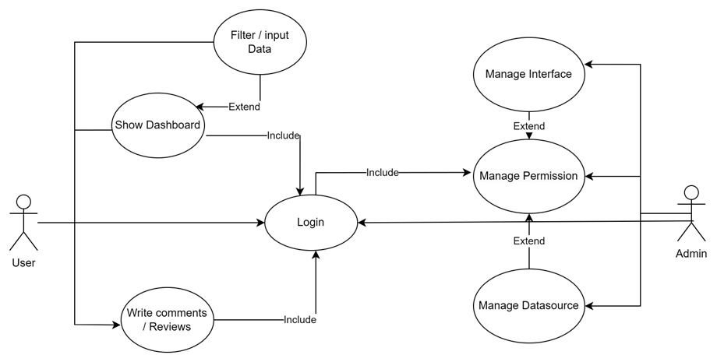
Figure 2 : DFD (data flow diagram)

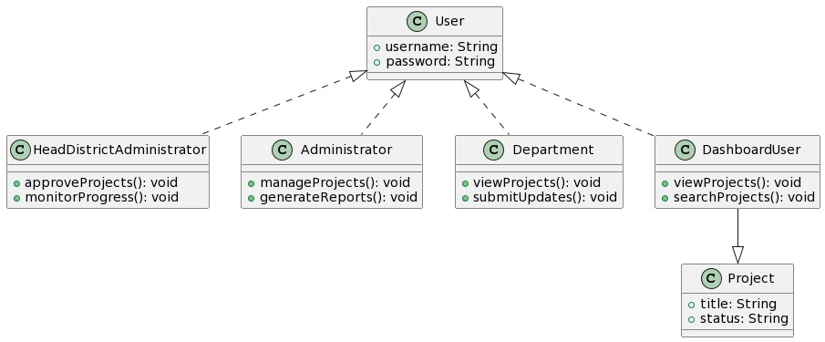
Figure 3 : ER Model - 1

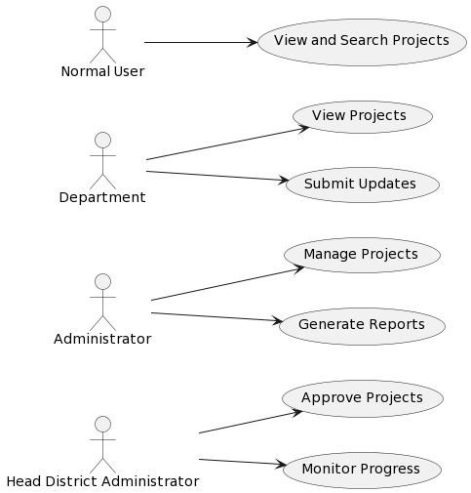
Figure 4 : Use Case Diagram

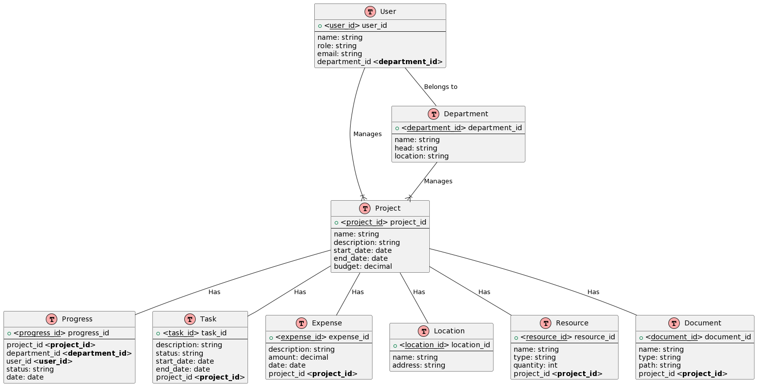
Figure 5 : ER Model – 2

CHAPTER IV
SYSTEM REQUIREMENTS
  - Software Requirements
The software requirements encompass a comprehensive array of tools, frameworks, and technologies necessary for the development, deployment, and maintenance of the District Integrated Dashboard. Each software component plays a crucial role in facilitating specific functionalities and ensuring the seamless integration of diverse modules within the dashboard.
- Front-end Technologies:
  - HTML: The backbone of web development, HTML provides the structural framework for the dashboard's user interface, defining the layout and organization of content.
  - CSS: Cascading Style Sheets (CSS) are utilized to enhance the visual presentation of the dashboard, including aspects such as colors, fonts, and layouts.
  - JavaScript: JavaScript is employed to add interactivity and dynamic functionality to the dashboard, enabling features such as real-time updates and data visualization.
  - React.js: As a JavaScript library, React.js facilitates the creation of reusable UI components, streamlining development and enhancing user experience.
- Back-end Technologies:
  - Python: Python serves as the core programming language for the back-end development of the dashboard, offering versatility, ease of development, and a rich ecosystem of libraries and frameworks.
  - Django or Flask: Frameworks like Django or Flask are utilized to accelerate back-end development, providing robustness, scalability, and security features essential for handling complex data processing and integration tasks.
- Database Management System (DBMS):
  - PostgreSQL: PostgreSQL is chosen as the preferred database management system for the District Integrated Dashboard, offering reliability, scalability, and advanced features for data storage and retrieval.
  - SQLAlchemy: SQLAlchemy, a Python SQL toolkit and Object-Relational Mapping (ORM) library, is employed to facilitate seamless interaction between Python and the PostgreSQL database, simplifying database operations and enhancing performance.
- API Integration:
  - RESTful APIs: The dashboard integrates with various external systems and data sources through RESTful APIs, enabling the retrieval and exchange of data in a standardized and efficient manner.
  - Third-party APIs: Additional third-party APIs may be utilized to access external services and functionalities, enhancing the dashboard's capabilities and expanding its integration possibilities.
- Version Control and Collaboration:
  - Git: Git is employed as the version control system for the project, facilitating collaboration, code management, and tracking of changes across multiple developers and contributors.
  - GitHub: GitHub serves as the hosting platform for the project's Git repositories, providing a centralized location for code storage, issue tracking, and collaboration among team members.
- Development Environment and Tools:
  - Integrated Development Environment (IDE): IDEs such as Visual Studio Code or PyCharm are utilized for code development, offering features such as syntax highlighting, debugging, and code completion.
  - Package Management: Package managers like pip for Python are used to install and manage project dependencies, ensuring consistency and compatibility across development environments.
  - Testing Frameworks: Testing frameworks such as pytest are employed to automate testing processes, ensuring the reliability, functionality, and performance of the dashboard.
- Deployment and Hosting:
  - Docker: Docker containers are utilized for containerization, enabling the packaging of the dashboard and its dependencies into lightweight, portable units for deployment across different environments.
  - Amazon Web Services (AWS) or Heroku: Cloud platforms like AWS or Heroku are chosen for hosting and deploying the dashboard, offering scalability, reliability, and infrastructure-as-a-service (IaaS) capabilities.
In summary, the software requirements encompass a diverse set of tools and technologies essential for the development, deployment, and maintenance of the District Integrated Dashboard. Each software component contributes to the overall functionality, performance, and user experience of the dashboard, ensuring its effectiveness in meeting the specific needs of Mehsana's administrative framework.
  - Hardware Requirements
The hardware requirements for the District Integrated Dashboard encompass the infrastructure components necessary to support the deployment and operation of the platform. From server resources to networking equipment, each hardware element contributes to the reliability, performance, and scalability of the dashboard in catering to the demands of Mehsana's administrative landscape.
- Server Infrastructure:
  - Processor: Multi-core processors with sufficient processing power are essential to handle concurrent user requests, data processing tasks, and computational requirements.
  - Memory (RAM): A substantial amount of RAM is necessary to support the concurrent execution of applications, data caching, and temporary storage of data in memory.
  - Storage: High-speed, reliable storage solutions such as Solid State Drives (SSDs) or Network Attached Storage (NAS) devices are employed to store application data, database files, and other assets.
  - Redundancy: Redundant components, including redundant power supplies, RAID configurations, and backup systems, are implemented to minimize downtime and ensure data integrity in case of hardware failures.
- Networking Infrastructure:
  - Network Bandwidth: Sufficient network bandwidth is required to facilitate seamless communication between users and the dashboard, ensuring fast data transfer speeds and low latency.
  - Load Balancers: Load balancers distribute incoming network traffic across multiple servers or resources, optimizing resource utilization and enhancing scalability and availability.
  - Firewalls and Security Appliances: Firewalls, Intrusion Detection Systems (IDS), and other security appliances are deployed to protect the dashboard from unauthorized access, malicious attacks, and data breaches.
- Environmental Considerations:
  - Cooling Systems: Effective cooling systems, including air conditioning units or liquid cooling solutions, are essential to maintain optimal operating temperatures for server hardware and prevent overheating.
  - Power Supply: Reliable power supply units, uninterruptible power supplies (UPS), and power distribution units (PDUs) are installed to ensure continuous operation and mitigate the risk of power outages.
- Scalability and Expansion:
  - Scalable Architecture: The hardware infrastructure is designed to be scalable, allowing for the addition of resources such as servers, storage devices, and networking equipment to accommodate increasing user demands and data volumes.
  - Modular Design: The architecture follows a modular design approach, enabling the seamless integration of additional hardware components or upgrades without disrupting the overall system functionality.
  - Cloud Services: Leveraging cloud services such as Amazon Web Services (AWS) or Microsoft Azure provides the flexibility to scale resources on-demand, dynamically adjusting compute, storage, and networking capacities based on workload requirements.
- Monitoring and Management:
  - Monitoring Tools: Robust monitoring tools and software solutions are implemented to monitor the health, performance, and availability of hardware components in real-time. These tools provide insights into resource utilization, system metrics, and potential issues, enabling proactive maintenance and troubleshooting.
  - Remote Management: Remote management capabilities allow administrators to remotely access and manage hardware resources, perform maintenance tasks, and troubleshoot issues without physical presence, enhancing operational efficiency and flexibility.
- Compliance and Security:
  - Compliance Standards: The hardware infrastructure adheres to industry standards and compliance regulations, ensuring data privacy, security, and regulatory compliance requirements are met. This includes measures such as encryption, access controls, and data integrity checks.
  - Physical Security: Physical security measures such as access controls, surveillance cameras, and secure facilities are implemented to protect the hardware infrastructure from unauthorized access, theft, or tampering.
- Cost Considerations:
  - Cost-Effective Solutions: Cost-effective hardware solutions are selected based on performance requirements, scalability needs, and budget constraints. This includes considerations such as Total Cost of Ownership (TCO), return on investment (ROI), and long-term sustainability.
  - Resource Optimization: Resource optimization strategies are employed to maximize hardware utilization and minimize unnecessary expenses. This includes techniques such as virtualization, consolidation, and resource pooling to optimize resource allocation and reduce operational costs.
In conclusion, the hardware requirements for the District Integrated Dashboard are meticulously designed to ensure scalability, reliability, performance, and security. By investing in robust infrastructure components, adhering to industry best practices, and leveraging scalable technologies, the hardware infrastructure lays a solid foundation for the successful deployment and operation of the dashboard, meeting the evolving needs of Mehsana's administrative framework.

CHAPTER V
EXPECTED OUTCOMES
The District Integrated Dashboard project is expected to yield significant outcomes that revolutionize administrative processes in Mehsana. With a user-friendly graphical user interface (GUI) at its forefront, the dashboard promises to enhance transparency, streamline decision-making, and optimize resource allocation.
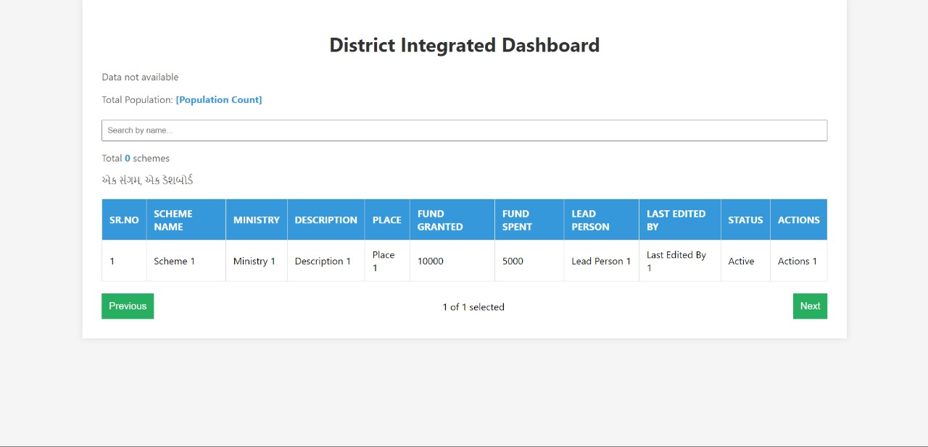
Figure 6 : Expected Outcome GUI
- Enhanced Transparency:
- The GUI of the District Integrated Dashboard will provide stakeholders with transparent access to real-time updates on ongoing projects and schemes across various departments.
- Through interactive charts, graphs, and data visualization tools, users will gain insights into project progress, expenditures, and outcomes, fostering accountability and transparency in administrative processes.
- Transparency will be further augmented through customizable dashboards, allowing users to tailor their views based on specific projects, departments, or key performance indicators (KPIs).
- Streamlined Decision-Making:
- The intuitive design of the dashboard's GUI will facilitate informed decision-making by presenting complex data in a user-friendly manner.
- Decision-makers will have access to comprehensive reports, analytics, and trend analysis tools, enabling them to identify patterns, anomalies, and areas for improvement across Mehsana's administrative landscape.
- With features such as drill-down functionality and comparative analysis tools, users can delve deeper into data insights, empowering them to make strategic decisions with confidence.
- Optimized Resource Allocation:
- The GUI of the District Integrated Dashboard will empower administrators to optimize resource allocation by providing visibility into project timelines, budgets, and resource utilization.
- Through interactive project timelines and resource allocation charts, users can identify bottlenecks, allocate resources efficiently, and prioritize projects based on their strategic importance and impact.
- The dashboard's GUI will enable users to track key performance metrics and monitor the return on investment (ROI) of projects, facilitating data-driven decisions and resource optimization strategies.
- User-Centric Design:
- The GUI of the District Integrated Dashboard is designed with a user-centric approach, prioritizing ease of use, accessibility, and intuitive navigation.
- User personas and usability testing are incorporated into the design process to ensure that the dashboard meets the diverse needs and preferences of its users, including district administrators, department heads, and project managers.
- Features such as customizable dashboards, role-based access controls, and multi-device compatibility enhance user experience and engagement, fostering adoption and utilization of the dashboard across Mehsana's administrative framework.
- Interactive Data Visualization:
- The GUI of the District Integrated Dashboard will feature interactive data visualization tools, including charts, graphs, maps, and heatmaps, to present complex data in a visually appealing and comprehensible format.
- Users can interact with data visualizations to drill down into specific data points, filter information based on criteria, and conduct ad-hoc analysis, enabling them to derive actionable insights and derive actionable insights and make informed decisions.
- With features such as hover-over tooltips, zoom functionality, and interactive legends, users can explore data visualizations with ease, enhancing their understanding and interpretation of complex datasets.
- Scalability and Flexibility:
- The GUI of the District Integrated Dashboard is designed to be scalable and flexible, capable of accommodating future enhancements, integrations, and expansions.
- Modular design principles and scalable architecture ensure that the dashboard can adapt to evolving user requirements, technological advancements, and changes in Mehsana's administrative landscape.
- APIs and integration capabilities allow the dashboard to seamlessly integrate with external systems, databases, and data sources, extending its functionality and interoperability beyond its core features.
In summary, the expected outcomes of the District Integrated Dashboard with GUI encompass enhanced transparency, streamlined decision-making, optimized resource allocation, user-centric design, interactive data visualization, scalability, and flexibility.

CHAPTER VI
CONCLUSION & FUTURE SCOPE
The District Integrated Dashboard project marks a significant milestone in the digital transformation of administrative processes in Mehsana. As we conclude this endeavor, it's essential to reflect on the achievements, challenges overcome, and the path forward for continued innovation and improvement.
  - Conclusion
The development and deployment of the District Integrated Dashboard represent a collaborative effort to address the pressing challenges faced by Mehsana's administrative framework. Through meticulous planning, iterative development, and stakeholder engagement, the dashboard has emerged as a powerful tool for enhancing transparency, streamlining decision-making, and optimizing resource allocation. With its intuitive graphical user interface (GUI), comprehensive data visualization capabilities, and scalable architecture, the dashboard stands poised to revolutionize administrative processes and drive positive outcomes for Mehsana's district administration.
- Key Achievements:
- Enhanced Transparency: The dashboard provides stakeholders with transparent access to real-time updates on ongoing projects and schemes, fostering accountability and trust.
- Streamlined Decision-Making: Decision-makers have access to comprehensive reports, analytics, and trend analysis tools, enabling them to make informed decisions with confidence.
- Optimized Resource Allocation: Administrators can optimize resource allocation by identifying bottlenecks, allocating resources efficiently, and prioritizing projects based on strategic importance and impact.
- Challenges Overcome:
- Data Integration: Integrating data from disparate sources and departments posed a significant challenge during the development process. However, through standardized APIs, data connectors, and iterative refinement, we successfully addressed this challenge and ensured seamless data aggregation and synchronization.
- User Adoption: Ensuring user adoption and engagement was another challenge, given the diverse user base and varying levels of technological proficiency. User-centric design principles, usability testing, and training programs helped mitigate this challenge and fostered acceptance and utilization of the dashboard.
  - Future Scope
While the District Integrated Dashboard has achieved significant milestones, its journey does not end here. There are several avenues for future enhancement and expansion, ensuring the dashboard remains at the forefront of administrative innovation and meets the evolving needs of Mehsana's district administration.
- AI Chat Bot Integration:
One exciting avenue for future development is the integration of an AI-powered chatbot within the dashboard. This chatbot could serve as a virtual assistant, providing users with real-time updates, answering queries, and assisting with tasks such as project status inquiries, data analysis, and report generation. The chatbot's natural language processing (NLP) capabilities would enhance user interaction and streamline communication, making the dashboard more accessible and user-friendly.
- Advanced Analytics and Predictive Modeling:
Another area for future enhancement is the incorporation of advanced analytics and predictive modeling capabilities within the dashboard. By leveraging machine learning algorithms and predictive analytics, the dashboard could forecast project outcomes, identify potential risks and opportunities, and recommend proactive interventions. These predictive insights would empower decision-makers to anticipate future challenges and make strategic decisions to mitigate risks and capitalize on opportunities effectively.
- Enhanced Integration and Interoperability:
Continued focus on enhancing integration capabilities and interoperability with external systems and databases is essential for the dashboard's future success. By expanding API integrations, supporting additional data formats, and fostering collaboration with external stakeholders, the dashboard can further enrich its data ecosystem and provide users with a comprehensive view of Mehsana's administrative landscape.
- Usability and Accessibility Improvements:
Continuous refinement of usability and accessibility features is crucial to ensure the dashboard remains inclusive and accessible to all users. This includes further customization options, multi-language support, and accessibility enhancements for users with disabilities. By prioritizing inclusivity and user experience, the dashboard can maximize its impact and reach across Mehsana's diverse administrative framework.
In conclusion, the District Integrated Dashboard project represents a transformative initiative that has the potential to redefine administrative processes and drive positive outcomes for Mehsana's district administration. Through enhanced transparency, streamlined decision-making, and optimized resource allocation, the dashboard empowers stakeholders with actionable insights and data-driven solutions. Looking ahead, the integration of AI chatbots, advanced analytics, enhanced integration capabilities, and usability improvements promise to elevate the dashboard's capabilities and ensure its continued relevance and impact in the evolving administrative landscape of Mehsana.

CHAPTER VII
REFERENCES
The foundation of knowledge upon which this Software Requirements Specification (SRS) is built, providing credibility and validation to the concepts and methodologies outlined within:

[1] Patel Rudra Jayeshkumar | New India vibrant Hackathon 2023 SSIP report | District Integrated Dashboard | 206-207 | 2023
[2] Basyurt A S | Government agency SMA dashboard | Front-end and Back-end Technologies | 2022
[3] Sukumar Ganapati | Dashboards in Government | Decision-Making in Governance | 2011
[4] Ketan Joshi | BI Dashboard utility | Business Intelligence for Government | 2017
[5] Paterne Chokki | NB Dash | Dashboard Design and Functionality | 2021
[6] Véronique L L C Bos | COVID-19 Dashboard | Pandemic Response Dashboards | 2021
[7] Greet Jans | DashHov: e-Government Dashboard | Usability in Government Dashboards | 2006
[8] Gupta Akash | Enhancing Government Data Portals: A Security Analysis | Data Security in Government Portals | 2017
[9] Jawa Anak | Real-time Integrated Dashboard for Efficient Road Construction Progress Monitoring | Infrastructure Project Monitoring | 2021
[10] Arun Mitra, Biju Soman, Gurpreet Singh | An Interactive Dashboard for Tracking COVID-19 in India | Pandemic Tracking Dashboard | 2021
[11] Sidharth Patel | Optimizing Administrative Efficiency through Digital Dashboards | Administrative Efficiency Dashboards | 2018
[12] Kumar Rao | Challenges in Data Integration for Government Projects | Data Integration in Government | 2019
[13] Parmenter, D. | Key Performance Indicators: Developing, Implementing, and Using Winning KPIs. | Hoboken, NJ: John Wiley & Sons Inc. | 2010
[14] Alexander, M., and Walkenbach, J. | Excel Dashboards and Reports. | Hoboken, NJ: John Wiley & Sons. | 2010
[15] Pierce, B. | Patent Failure: The USPTO’s Oversized but Undernourished New Dashboard. | Visual Business Intelligence: A blog by Stephen Few. | 2010
[16] Park, S. Y., & Jamieson, W. | Developing a Tourism Destination Monitoring System: A Case of the Hawaii Tourism Dashboard. | Asia Pacific Journal of Tourism Research, 14(1), 39–57 | 2009
[17] Rasmussen, N. H., Bansal, M., & Chen, C. Y. | Business Dashboards: A Visual Catalog for Design and Deployment. | Hoboken, NJ: John Wiley and Sons. | 2009
[18] Tufte, E. R. | Beautiful Evidence. | Cheshire, CT: Graphics Press. | 2006
[19] Lam, J. | Overview of Enterprise Risk Management. | In Handbook of Finance, edited by F. J. Foury. | Hoboken, N.J.: Wiley and Sons. | 2008
[20] Tufte, E. R. | Executive Dashboards. | 2003
[21] Richardson, J. | Tips for Implementers: The Basics of Good Dashboard Design. | Gartner RAS Core Research Note G00171685. | 2009
[22] Thomsen, E. | OLAP Solutions: Building Multidimensional Information Systems. | Hoboken, NJ: John Wiley & Sons. | 1997
[23] Grimes | Whacky Graphics at USAspending.gov | InformationWeek’s Microsoft Weblog | 2009

[24] White House. | Transparency and Open Government. (Presidential Documents). Federal Register, 74(15), 4685–4686. | 2011
[25] Lathrop, D., & Ruma, L. | Open Government: Collaboration, Transparency, and Participation in Practice. | Sebastopol, CA: O’Reilly Media. | 2010
[26] Few, S.|Information Dashboard Design: The Effective Visual Communication of Data|2006
[27] Few, S.|Now You See it: Simple Visualization Techniques for Quantitative Analysis|2009
[28] Ballou, B., Heitger, D., & Donnell, L.|Creating Effective Dashboards|Strategic Finance, 91(9), 27–32|2010
[29] USPTO (U.S. Patent and Trademark Office). | Performance and Accountability Report Fiscal Year 2010. | 2011
[30] Bourguignon, A., Malleret, V., & Nørreklit, H.|The American Balanced Scorecard Versus the French Tableau de Bord: The Ideological Dimension|Management Accounting Research, 15(2), 107–134|2004
[31] Matthews, W. | Federal IT Dashboard Not Winning Manager Hearts. | Nextgov: Technology and the Business of Government. | 2011
[32] Gasmelseid, T. M. | From Operational Dashboards to E-Business: Multiagent Formulation of Electronic Contracts | International Journal of E-Business Research, 3(3), 74–88, 90–94 | 2007
[33] OMBWatch. | Interim Recovery.gov Data Reporting Architecture. | 2009
[34] Tufte, E. R. | The Visual Display of Quantitative Information. | Cheshire, CT: Graphics Press. | 2001
[35] Watchdog.org. | $6.4 Billion Stimulus Goes to Phantom Districts. | 2009
[36] Bumiller, E.|We Have Met the Enemy and He is PowerPoint|New York Times, A1|2010
[37] Few, S.|Federal CIO Dashboard: We Can and Should Do Better Than This|Visual Business Intelligence: A Blog by Stephen Few|2009
[38] Kundra, V. | Open Sourcing the IT Dashboard & the TechStat Process. | The White House Blog. | 2011
[39] Hanselman, O. | Uniting Strategy with Action Using a “Performance Dashboard.” | Journal of Performance Management, 22(3), 35–46 | 2009
[40] GAO | Recovery Act: Opportunities to Improve Management and Strengthen Accountability over States’ and Localities’ Uses of Funds | 2010
[41] Epstein, M., & Manzoni, J. F.|Implementing Corporate Strategy: From Tableaux de Bord to Balanced Scorecards|European Management Journal, 16(2), 190–203|1998
[42] Clarke, S.|Your Business Dashboard: Knowing When to Change the Oil|Journal of Corporate Accounting & Finance, 16(2), 51–54|2005
[43] UBMatrix. | Recovery.gov and Extensible Business Reporting Language (XBRL). | 2009
[44] Eckerson, W. W.|Performance Dashboards: Measuring, Monitoring, and Managing Your Business|2006
[45] Jarke, M., Lenzerini, M., Vassiliou, Y., Vassiliadis, P. | Fundamentals of Data Warehouses. 2nd Edition. | NY: Springer. | 2003
[46] GAO (Government Accountability Office). | Recovery Act: Recipient Reported Jobs Data Provide Some Insight into Use of Recovery Act Funding, but Data Quality and Reporting Issues Need Attention | 2009
[47] Arun Mitra, Biju Soman, Gurpreet Singh | An Interactive Dashboard for Tracking COVID-19 in India | Pandemic Tracking Dashboard | 2021
[48] Sidharth Patel | Optimizing Administrative Efficiency through Digital Dashboards | Administrative Efficiency Dashboards | 2018
[49] Kumar Rao | Challenges in Data Integration for Government Projects | Data Integration in Government | 2019
[50] Orszag, P. | Memorandum for the Heads of Executive Departments and Agencies. | 2009
[51] Kaplan, R. S. & Norton, D. P. | The Balanced Scorecard: Translating Strategy into Action. | Boston, MA: Harvard Business School Press. | 1996
[52] Miller, E. | Testimony before the Committee on Oversight and Government Reform, Subcommittee on Technology, Information Policy, Intergovernmental Relations, and Procurement Reform, United State House of Representatives on Transparency through Technology: Evaluating Federal Open Government Efforts. | 2011
[53] Kundra, V. | 25 point Implementation Plan to Reform Federal Information Technology Management. | 2010
[54] Frolick, M. N. & Ariyachandra, T. R.| Business Performance Management: One Truth|Information Systems Management, 23(1), 41–48|2006
[55] Muras, A., Smith, T., & Meyers, D. | Simple, Effective Performance Management: A TopDown and Bottom-Up Approach. | Journal of Corporate Accounting & Finance, 20(1), 65-73. | 2008
[56] Inmon, W. H., Welch, J. D., & Glassey, K.L. | Managing the Data Warehouse. | Hoboken, NJ: John Wiley & Sons. | 1997
[57] Love, J., & Resnick, A. | Getting on the Same Page: Dashboard Development From Planning to Implementation. | Cutter IT Journal, 19(4), 6-12. | 2006
[58] Edwards, D., & Thomas, J. C.|Developing a Municipal Performance-Measurement System: Reflections on the Atlanta Dashboard|Public Administration Review, 65(3), 369–376|2005
[59] GAO | Information Technology: OMB’s Dashboard has Increased Transparency and Oversight, but Improvements Needed | 2010
[60] GAO | Information Technology: OMB Has Made Improvements to its Dashboard, but Further Work is Needed by Agencies and OMB to Ensure Data Accuracy | 2011
[61] Pauwels, K., Ambler, T., Clark, B., LaPointe, P., Reibstein, D., Skiera, B., Wierenga, B., & Wiesel, T. | Dashboards as a Service: Why, What, How, and What Research Is Needed? | Journal of Service Research: JSR, 12(2), 175–189 | 2009
[62] Gasmelseid, T. M. | From Operational Dashboards to E-Business: Multiagent Formulation of Electronic Contracts | International Journal of E-Business Research, 3(3), 74–88, 90–94 | 2007
[63] Gitlow, H. S. | Organizational Dashboards: Steering an Organization Towards its Mission | Quality Engineering, 17(3), 345–357 | 2005
[64] Whacky Graphics at USAspending.gov | InformationWeek’s Microsoft Weblog | 2009
[65] Uniting Strategy with Action Using a “Performance Dashboard.” | Journal of Performance Management, 22(3), 35–46 | 2009
[66] Dashboard Technology: Is it a Helping Hand or a New Big Brother? | The Wall Street Journal, B1 | 2005
[67] Tufte, E. R. | Beautiful Evidence. | Cheshire, CT: Graphics Press. | 2006
[68] UBMatrix. | Recovery.gov and Extensible Business Reporting Language (XBRL). | 2009
[69] USPTO (U.S. Patent and Trademark Office). | Performance and Accountability Report Fiscal Year 2010. | 2011
[70] Watchdog.org. | $6.4 Billion Stimulus Goes to Phantom Districts. | 2009
[71] White House. | Transparency and Open Government. (Presidential Documents). Federal Register, 74(15), 4685–4686. | 2011

